AI Personal Assistant using n8n, Streamlit, and Ollama

Project Report

1. Introduction
The AI Personal Assistant is an automation-based intelligent assistant developed using n8n, Streamlit, and Ollama Local LLM. The system is designed to perform multiple assistant-related tasks such as answering user questions, managing emails, handling notes, tracking expenses, managing tasks, and arranging calendar events.
The project integrates workflow automation with conversational AI to create a centralized assistant platform. The frontend is built using Streamlit, while n8n is used as the workflow orchestration engine. Ollama is used as the local Large Language Model (LLM) to reduce dependency on expensive cloud-based APIs.
This project demonstrates practical implementation of:
- AI-powered conversational systems
- Workflow automation
- API integration
- Local LLM deployment
- Task and productivity automation
- Email and calendar management

2. Objectives
The main objectives of this project are:
- To create an intelligent personal assistant.
- To automate repetitive productivity tasks.
- To integrate multiple tools into a single workflow.
- To reduce dependency on paid AI APIs.
- To provide an interactive chat interface.
- To demonstrate practical use of n8n workflows.

3. Technologies Used
Technology | Purpose
Python | Backend scripting
Streamlit | User interface
n8n | Workflow automation
Ollama | Local AI model execution
Gmail API | Email management
Google Calendar API | Event management
SerpAPI | Web search functionality
HTTP Webhooks | Communication between frontend and n8n

4. System Architecture
The system follows a modular architecture:
- User sends a message from the Streamlit interface.
- The message is sent to the n8n webhook.
- The AI Agent processes the request.
- Depending on the request type, different tools are triggered.
- Ollama generates the AI response.
- The response is returned to Streamlit and displayed to the user.

5. n8n Workflow Description
The n8n workflow contains multiple integrated tools connected with an AI Agent.

Main Components

5.1 Webhook
Receives requests from the Streamlit frontend.

5.2 AI Agent
Acts as the central controller that decides which tool or workflow should be executed.

5.3 Ollama Chat Model
Processes user prompts locally using a downloaded LLM.

5.4 Memory Module
Stores previous conversation context for better responses.

5.5 Gmail Tools
- Get Single Message
- Get Message List
- Send Message
These tools allow the assistant to read, summarize, and send emails.

5.6 Google Calendar Tools
- Create Event
- Get Event
- Get Calendar Event
These tools help manage meetings and schedules.

5.7 Notes Tools
- Create Notes
- Update Notes
- Get Notes
Allows users to store and retrieve notes.

5.8 Expense Tracking
- Add Expense
- Get Expense
- Calculator
Used for expense management and calculations.

5.9 Task Tools
- Create Task
- Get Single Task
- Get Multiple Tasks
- Delete Task
Allows task management operations.

5.10 SerpAPI Search
Used to retrieve information from the internet.

6. Workflow Screenshot

Complete n8n Workflow
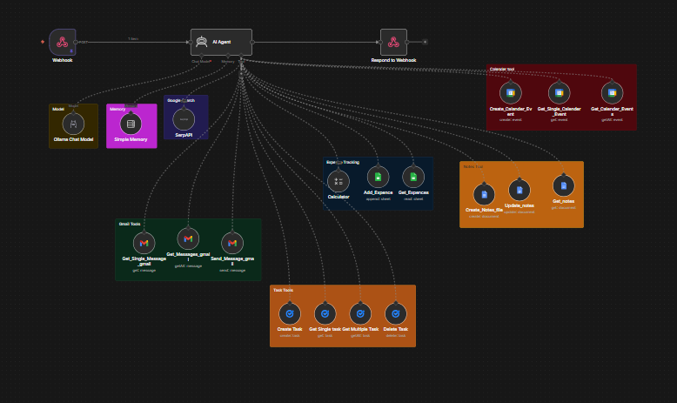

Description of Workflow
The workflow connects multiple productivity tools with a centralized AI agent. The AI agent dynamically selects the required operation based on the user prompt.

7. Streamlit Frontend Code Explanation
The Streamlit frontend provides an interactive chat interface for users.

Main Features
- Chat-based interface
- Session-based chat history
- Communication with n8n webhook
- Real-time AI responses
- User-friendly UI

Important Components

Title and Description
The application introduces the assistant and displays supported functionalities.

Session State
Used to maintain chat history during interaction.

Chat Input
Allows users to send messages to the assistant.

Webhook Communication
The frontend sends user messages to the n8n webhook using HTTP POST requests.

AI Response Display
Displays responses received from the AI assistant.

Streamlit Code:
import streamlit as st
import requests

# create the title for the page
st.title("🤝 Your Personal Assistant")

# add subheader
st.subheader("What can your personal assistant do?")

# create a list of what your assistant can do
st.markdown("""
1. Answer questions on various topics.
2. Arrange Calendar events and meetings.
3. Read your emails and send replies, can even summarize them for you.
4. Manage your tasks and to-do lists.
5. Take quick notes for you.
6. Track your expenses and budgeting.
""")

# add chats subheader
st.subheader("💬 Chat with your assistant")

# create a session state for message history
if "messages" not in st.session_state:
st.session_state.messages = []

# show the messages in chat history
for message in st.session_state.messages:
with st.chat_message(message["role"]):
st.markdown(message["content"])

# create a chat input box
user_message = st.chat_input()

# if user sends a message
if user_message:
with st.chat_message("user"):
st.markdown(user_message)
# append the user message to message history
st.session_state.messages.append({"role": "user", "content": user_message})

# send the user message to the n8n webhook
response = requests.post(
"http://localhost:5678/webhook/c978d29e-b7cb-42a5-88f0-ab228f8e3b50", # n8n webhook URL
json={"message": user_message}
)

# get the AI response from webhook
ai_response = response.json()[0]["output"]

# display the AI response in chat
with st.chat_message("assistant"):
st.markdown(ai_response)
# append the AI response to message history
st.session_state.messages.append({"role": "assistant", "content": ai_response})

8. Webhook Testing Code
A separate Python script was used for testing the webhook independently.

Purpose of Testing Script
- Validate webhook connectivity
- Verify response format
- Test AI responses
- Debug API communication
The test script sends a prompt to the webhook and prints the response.
import requests

user_message = "Can you tell me about black holes in 3 to 4 lines?"

request_message = {"message": user_message}

url = "http://localhost:5678/webhook-test/c978d29e-b7cb-42a5-88f0-ab228f8e3b50"

response = requests.post(url, json=request_message)

print(response.status_code)

print(response.text)

print(response.json()[0]["output"])

9. Features of the AI Assistant

9.1 Question Answering
The assistant can answer general knowledge and educational questions.

9.2 Email Management
Users can:
- Read emails
- Summarize emails
- Send replies
- Retrieve email lists

9.3 Calendar Management
Users can:
- Create events
- Retrieve events
- Manage schedules

9.4 Task Management
Users can:
- Create tasks
- View tasks
- Delete tasks

9.5 Notes Management
Users can:
- Create notes
- Update notes
- Retrieve notes

9.6 Expense Tracking
Users can:
- Add expenses
- Retrieve expense records
- Perform calculations

9.7 Internet Search
The assistant can search the web using SerpAPI.

10. Testing and Results
The system was tested using different prompts to validate functionality.

Sample Test Cases
Test Case | Expected Result | Status
Ask AI question | AI returns response | Passed
Create calendar event | Event created successfully | Passed
Send email | Email sent successfully | Passed
Create note | Note saved successfully | Passed
Add expense | Expense recorded | Passed
Search internet | Search results returned | Passed

11. Placeholders for Working Screenshots

Screenshot 1 – Streamlit Home Interface
Prompt Used:
"Hello Assistant"
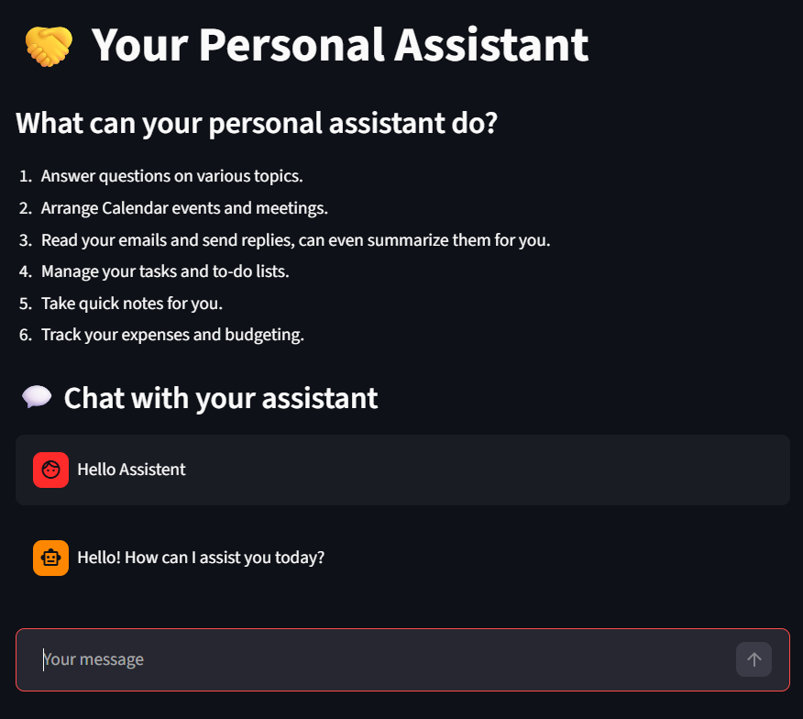

Screenshot 2 – AI Question Answering
Prompt Used:
"Can you tell me about black holes in 3 to 4 lines?"
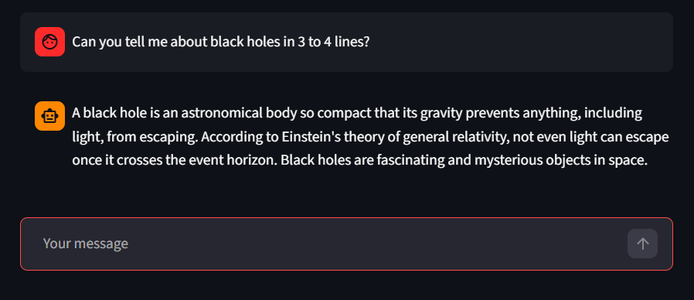

Screenshot 3 – Email Retrieval
Prompt Used:
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 client sec
707620872771-vr2ipdgn567b9qbgl016b2es1rk92rfe.apps.googleusercontent.com client id

Screenshot 4 – Sending Email
Prompt Used:
" Send an email to hammadyounisabbasihammadyounis@gmail.com about a meeting scheduled for tomorrow row at 5 PM. Include the meeting details and ask for confirmation. "
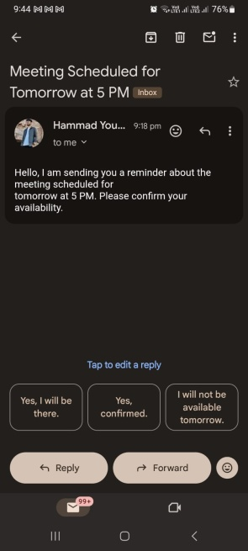

Screenshot 5 – Calendar Event Creation
Prompt Used:
"Create a meeting tomorrow at 5 PM"
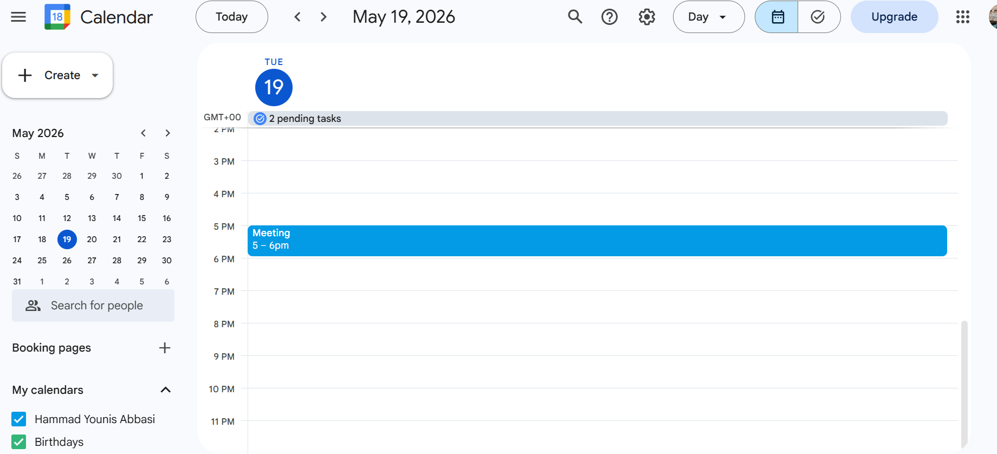

Screenshot 6 – Notes Management
Prompt Used:
"Create a note about project submission"
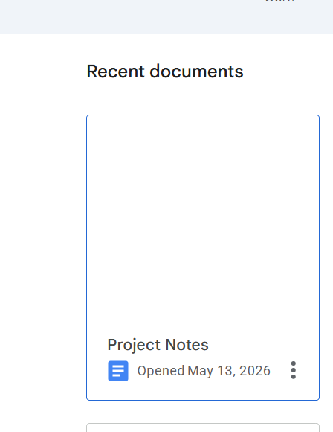

Screenshot 7 – Expense Tracking
Prompt Used:
" Using the Google Sheets tool, append a new row to the Finance_Tracking sheet with a 200 expense on Oil under the same Groceries category.”
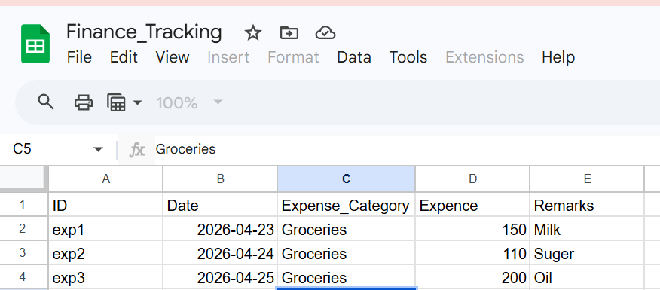

Screenshot 8 – Web Search
Prompt Used:
"Search latest AI news"
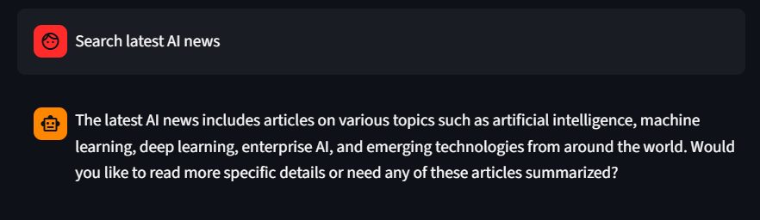

12. Advantages of the Project
- Centralized assistant system
- Automation of repetitive tasks
- Local AI processing for privacy
- Easy-to-use interface
- Modular workflow design
- Reduced dependency on cloud APIs
- Scalable architecture

13. Limitations
Although the system works successfully, some limitations were observed during development and testing.

13.1 Slow Performance
The application can become slow because the Ollama model runs locally on the personal computer. Large language models require significant CPU/RAM resources, which affects response time.

13.2 High Cost of OpenAI APIs
OpenAI APIs are expensive for continuous usage. Due to budget constraints, the project relies mainly on Ollama local models instead of cloud-based premium APIs.

13.3 Limited Google Search Tokens
The SerpAPI free plan provides approximately 250 search requests. Additional searches require paid subscriptions, which can become costly.

13.4 Hardware Dependency
The performance of the assistant depends heavily on the local machine specifications.

13.5 Internet Dependency for External Services
Some modules such as Gmail, Calendar, and SerpAPI require internet connectivity.

14. Future Improvements
The following improvements can be implemented in future versions:
- Add voice assistant support
- Add WhatsApp integration
- Deploy on cloud infrastructure
- Improve response speed using GPU acceleration
- Add authentication system
- Add multi-user support
- Add database storage for long-term memory
- Use advanced LLMs for better reasoning

15. Conclusion
The AI Personal Assistant project successfully demonstrates the integration of workflow automation, conversational AI, and productivity tools into a single intelligent system.
Using n8n as the automation engine and Streamlit as the frontend allowed the development of a flexible and scalable assistant. Ollama provided a cost-effective alternative to expensive cloud AI APIs.
The project highlights practical applications of AI automation in real-world productivity tasks such as email handling, scheduling, task management, note management, and expense tracking.
Overall, the project provides a strong foundation for developing advanced AI-powered automation systems.

